Countertop materials that stand up to years of abuse
By Consumer Reports News | ConsumerReports.org – Mon, Jun 17, 2013 11:00 AM EDT
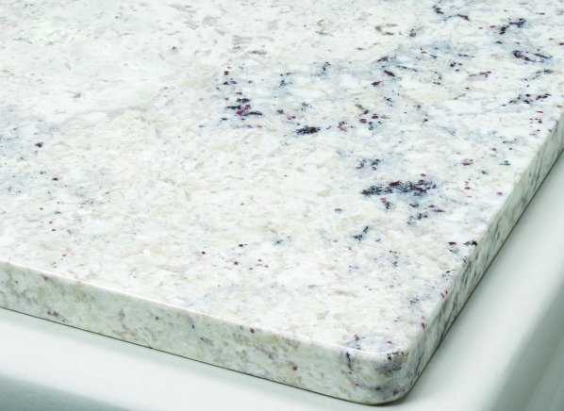
When shopping for kitchen appliances you'll see a dizzying array of choices, from basic models to ones loaded with features. But your countertops might outlast your appliances by years, maybe decades, making this decision one you'll live with for some time. Consumer Reports tested 14 materials and found that except for recycled glass, there wasn't much difference among competing brands, but there were big differences in materials. Here's a look at our tests and what's new in countertops.
Crazy about quartz. This synthetic material is becoming more popular and some mimics stone, although may look too uniform to be realistic. Quartz also comes in vivid colors such as Caeserstone's Apple Martini and Red Shimmer. Quartz was tops in our tests, whether polished or matte finish. Sharp knives, abrasive pads, hot pots, and most stains didn't damage it plus it's easy to maintain and doesn't require sealing. Silestone's suede series is designed to have a leathery finish with little reflection, but their website warns that this finish may require extra care.
CR tip: Edges and corners can chip and repairs aren't a DIY project. Rounded edges help.
Granite's rock solid rep. It's been rumored to be on its way out for years but granite is still among the most desirable or must-have kitchen features, according to a recent study from the National Association of Home Builders. No two slabs are exactly alike, giving your kitchen its own look, and unlike marble, limestone, and soapstone, granite is the only real stone that's practical enough for heavily used areas. It performed similarly to quartz in our tests and new suede and leathered finishes skip the high sheen and offer a softer look.
CR tip: When properly sealed, matte finish and polished granite fended off most stains, so reseal periodically to maintain resistance. Chipped edges and corners are a possibility and only a pro can repair them.
Shards of glass. When finely ground the look is subtle, while large shards of colorful glass create a unique and artsy look. The coastal collection from Vetrazzo features four offerings that celebrate the sea. With names like Bretagne Blue and Emerald Coast, these counters are made of iridescent oyster shells, crushed marble, and gorgeous glass. Most recycled glass counters we tested withstood cuts, heat, scratches, and stains, but of all the materials we tested, glass was the only one where there was a difference among brands. Cosentino's Eco counters developed a thin crack during our heat tests.
CR tip: Edges can chip, but a pro can fix this. Some manufacturers recommend rewaxing and resealing every six to 12 months.
Testing countertop materials is a lot like a dinner party gone crazy—food stains, scorch marks, nicks, and scratches, all in an effort to find durable materials that fit every budget. We test everything from solid surfacing and soapstone, laminate and limestone, besides bamboo. See the results of our countertop tests to find a material that works for your kitchen and budget.
For more on kitchen remodeling, check our new report, "Get the kitchen you've always wanted" and see the countertop choices three homeowners made in "Magnificent kitchen makeovers."
—Kimberly Janeway
from Consumer Reports:

